Logistics Case Study

Please note, that usage of Generative AI is not permitted.

In case of usage detected, case study would not be considered.

For this case study you will create a simple prototype of the forecasting model for one of the About You warehouses.

In the end we would like to know how many ordered items will be exported to a specific warehouse on a daily basis for each country based on the sales forecast.

The objective of this project is to create a data transformation that creates an operational forecast based on a provided sales forecast.

The operational forecast should in the end tell us how many items each warehouse will need to pick on a daily basis.

# Important notes:

## **Warehouse assignment and types of orders**:

o The location of the fulfillment process is dependent on the country where the order is coming from, meaning that every country has a default warehouse (here 1,2,3,4) that needs to fulfill the order (e.g. Poland is fulfilled by warehouse 1 and Slovakia by warehouse 2)

o However, for some orders not every item is available in the default warehouse to fulfill the order. In this case items have to be picked in a different warehouse which are then shipped to the default warehouse and consolidated with the remaining items. This process is called Cross-Docking

o There are 2 types of Cross-Docking:

o Shipment-Cross-Dock (**SCD**) = An order is entirely fulfilled by a warehouse that is **not** the default warehouse

o Item-Cross-Dock (**ICD**) = Only a sub-set of items from the order is picked at a non-default warehouse and shipped **to** the default warehouse for consolidation with the remaining items from the order that are picked at the default warehouse.

o If no Cross-Docking is required, the order is called a **regular** **B2C** order (all items of the order sourced from default warehouse) ; otherwise **B2C with item-cross dock** (some of the order positions were sourced from other warehouse) (labelled b2c_w_cd)

## **Warehouse perspectives**:

o If the type of the order line is **regular B2C** then the default warehouse is both **picking and shipping warehouse** for this line.

o If the type of the order line is **B2C with ICD** then for this line the default warehouse will be shipping and picking warehouse will be different.

o If the type of the order line is **SCD** then for all items of the order the default warehouse will be the shipping warehouse, but not the picking warehouse

*Image 1. Warehouse perspectives*

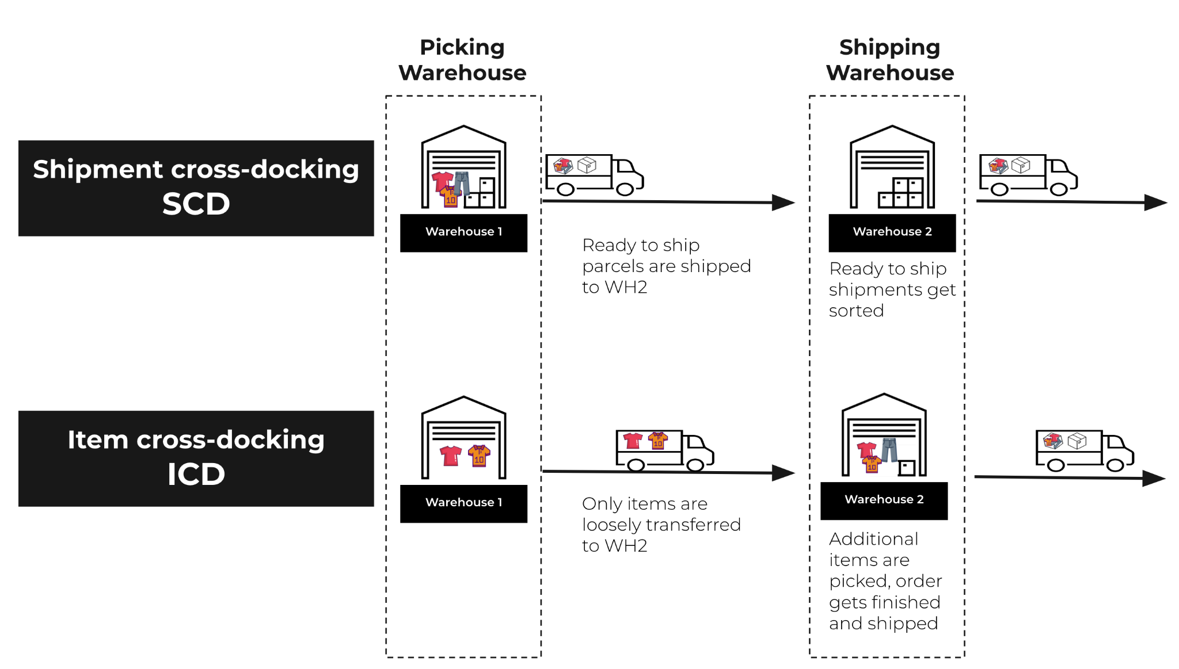

Example of an order with an Item Cross Dock (ICD) part:

| order_id | order_line_id | picking_warehouse_id | shipping_warehouse_id | Line type |
| --- | --- | --- | --- | --- |
| 10468237 | 345081678 | 1 | 1 | b2c_regular |
| 10468237 | 345081679 | 1 | 1 | b2c_regular |
| 10468237 | 345081680 | 2 | 1 | b2c_with_cd |

Example of an order that is Shipment Cross Dock (SCD):

| order_id | order_line_id | picking_warehouse_id | shipping_warehouse_id | Line type |
| --- | --- | --- | --- | --- |
| 10245123 | 345081512 | 1 | 2 | b2c_with_cd |
| 10245123 | 345081513 | 1 | 2 | b2c_with_cd |

## **Export rules**:

* There are 2 types of dates to keep in mind: **created_at** (the date of order creation, aka sale date on the website) and **exported_at** (the date of order export to the warehouse’s operational system).
* Orders can only be exported if a warehouse has all items available to fulfil it (independent of the created_at date).
* A **regular B2C order** is exported to the shipping warehouse at the same time as the order is created.
* If items need to be item-cross docked from another warehouse, then the B2C with ICD **order** is exported to the shipping warehouse **only when missing items** from the order arrive.
* SCD is exported to the picking warehouse at the same time as the order is created.

# Task

In order to plan capacities for the warehouse_id = 2, we need to know how many items will be **exported** each day to this warehouse.

## As input you will have:

1. B2C items sales forecast consolidated on created_at date (regular B2C + B2C with ICD)
2. SCD items sales forecast consolidated on created_at date
3. ICD items sales forecast consolidated on created_at
4. Assumption on how many items per ICD item are blocked from immediate export by the ICD process.
5. Assumption on how export of items is distributed (based on order creation date) for orders affected by ICD. This considers that some orders will take longer than others to be processed by the picking warehouse and then shipped and arrive at the shipping warehouse

## Steps to perform (each step results into dataframe):

1. Based on export rules, aggregate **B2C** (shipping warehouse) and **SCD** (picking warehouse) on exported_at for warehouse_id=2.
2. Aggregate **ICD** for shipping_warehouse_id=2 - this is the amount of items we forecast which will be needed to be sourced from other warehouses to fulfil the B2C orders in warehouse_id=2
3. Using results from point (B) of the and input (4), calculate how many items will be affected by item cross-docking process (items transported from picking warehouse + other items in the same order_id)

-> results in dataframe “**items_minus**”

1. Using “**items minus**”, calculate the distribution of exported items for each created_at and aggregate on exported_at

-> results in dataframe “**items_plus**”

1. Calculate final output: **B2C** + **SCD** - **items_minus** + **items_plus**

### Dataframes should have the structure

* Index: countries
* Columns: exported_at dates
* Values: Items